**Year 10 MODERN HISTORY - Nations and nation-states**

**Assessment 2 – Virtual Museum Research Task**

Weight: 25% of the course

**Name:** __________________________________________________________________________________________

**Teacher:** _______________________________________________________________________________________

**Due dates:**

**Proposition / hypothesis:** _________________________

**Museum display and reflection / rationale:** _________________________

**Task**

Students are to conduct an inquiry into a theme of causes and consequences that runs throughout our period of study of American History and use their findings to create a museum display.

The assessment has three parts:

1. Research,
2. Virtual Museum Display OR Crash Course OR Traditional Museum Display
3. Reflection/rationale.

The themes for students to choose are as follows:

**Economics: Work**

- focus on the transformation of the work environment in the United States and the nature of work due to developments in agriculture, commerce and manufacturing.

OR

**Politics: Politics and power**

- focus on the different social and political groups that have influenced the United States.

OR

**External: America in the world**

- focus on the influence of the United States on world affairs.

OR

**Social: Culture**

- focus on creative forms of expression (art, music, theatre, film) that have influenced the overall shaping

of the United States.

***YOUR HYPOTHESIS MUST INCLUDE AN EXPLORATION OF THE CAUSES AND CONSEQUENCES OF YOUR CHOSEN TOPIC IN AMERICAN HISTORY***

**Year 10 MODERN HISTORY - Nations and nation-states**

**Assessment Guidelines**

|  |  |  |  |
| --- | --- | --- | --- |
| **Step** | **Description** | **Due Date** | **Teacher sign/date** |
| **1** | Part A:   * Choose a theme from the list above. * Within this theme is a focus on key people, events and/or ideas throughout our period of study within those themes. |  |  |
| **2** | Part A continued:   * Develop **focus questions**, a proposition and/or hypothesis to guide your research. * Have your **proposition/hypothesis** confirmed with your teacher before progressing to Step 3. |  |  |
| **3** | Part A continued:   * Research your topic utilising your focus questions, proposition and/or hypothesis and create **Cornell research notes.** * Use a variety of methods to collect relevant evidence such as print, digital, visual, audio and fieldwork whilst utilising specific criteria to determine the best sources to support your historical inquiry. * Create an **annotated bibliography** for four (4) of your chosen sources. * Ensure that you record all other sources correctly in the Chicago referencing style presented in a **reference list.** |  |  |
| **4** | Submit Part A |  |  |
| **5** | Part B:   * Using a variety of evidence and your research, create a **virtual museum display** **or crash course** to show your findings to visually evaluate your hypothesis/theme. |  |  |
| **6** | Submit Part B |  |  |
| **7** | Part C:   * Write a 500 word **reflection/ rationale** that explains why you chose your topic and explain the purpose behind how and why you presented your them and an understanding of the causes and consequences of the events, people and ideas evaluated. |  |  |
| **8** | Submit Part C |  |  |

**END OF TASK REQUIREMENTS**

**Year 10 MODERN HISTORY - Nations and nation-states**

**Assessment #1 – Virtual Museum Research Task marking guide**

|  |  |  |  |
| --- | --- | --- | --- |
| **MARKING GUIDE** | | | |
| **Preparation and research**  **(Part A)** | **Hypothesis/proposition** | | |
| The hypothesis/proposition was presented to the teacher for consultation.  The hypothesis clearly indicates the focus of the task.  The hypothesis is followed throughout the task. | 3 |  |
| The hypothesis/proposition was presented to the teacher for consultation.  The hypothesis indicates the focus of the task.  The hypothesis is generally followed throughout the task. | 1-2 |
| The hypothesis/proposition was not presented to the teacher for consultation.  The hypothesis does not clearly indicate the focus of the task. | 0 |
| **Research** | | |
| Clear focus questions (>10) are stated and visibly relate to the hypothesis/proposition.  Clear, organised and effective use of Cornell notes/graphic organiser for research using focus questions presented. Research utilises the key historical themes in the analysis of events, ideas and/or people. | 10-11 |  |
| Some focus questions (<10) are stated and somewhat relate to the hypothesis/proposition.  Mostly uses Cornell notes/graphic organiser for research using focus questions presented. Research mentions historical themes using them to explore events, ideas and/or people | 6-9 |
| Questions are not focused to the theme/hypothesis/proposition.  Limited research using either Cornell, graphic organisers or another method of note taking presented. Research does not mention historical themes. | 3-5 |
| Focus questions do not meet the needs of the task and/or there is limited to no research with no use of Cornell notes presented. | 0-1 |
| **Annotated Bibliography (4 sources)** | | |
| All four (4) sources demonstrate the use of a wide range of academic information (at least four different journals, books or academic websites).  Provides a clear summary of the sources and any relevant findings or conclusions.  Provides a clear and thorough evaluation of the usefulness of the source in relation to the hypothesis/proposition and any limitations.  Identifies how this source will fit in with the research for this proposition/hypothesis. | 7-8 |  |
| All four (4) sources demonstrate the use of a wide range of information.  Provides some information pertaining to the source.  Provides some explanation of the usefulness of the source sometimes not related to the theme, and mostly overlooks limitations of the source.  Somewhat identifies how this source can be used. | 5-6 |
| Four (4) sources demonstrate a limited range of information used.  Provides limited information pertaining to the source.  Provides a vague explanation of the usefulness of the source sometimes not related to the theme, and mostly overlooks limitations of the source.  Limited identification of how this source can be used. | 2-4 |
| Four sources demonstrate no range of information or no sources presented.  Provides no information pertaining to the source.  Provides no explanation of the usefulness of the source sometimes not related to the theme, and overlooks limitations of the source.  No identification of how this source can be used. | 0 |
| **Reference List** | | |
| The reference list is in Chicago style and professionally presented and contains more than 10 academic sources. | 3 |  |
| The reference list is in Chicago style and professionally presented and contains less than 10 sources. | 2 |
| The reference list does not meet the requirements of Chicago style. | 0-1 |
| **Final mark for the preparation and research** | /25 | |
| **Museum display/ Crash Course**  **(Part B)** | **Historical understanding** | | |
| All information chosen for the display is directly relevant to the theme chosen and presents a valid historical response to the theme over our period of study demonstrating an evaluation of the theme. | 7-8 |  |
| Some information chosen for the display is relevant to the theme and mostly provides a historical response related to the theme over our period of study demonstrating a limited evaluation of the theme. | 4-6 |
| Limited information is chosen for the display and does not always relate to the theme and is not always historically accurate in our period of study and is limited in outlining the theme. | 1-3 |
| Information chosen for the display and is vague/not relevant to the theme and/or is historically inaccurate does not provide an evaluation of the theme. | 0 |
| **Organisation of information** | | |
| Information is detailed, clear and logically organised to effectively communicate the theme. | 4 |  |
| Information is mostly organised to somewhat effectively communicate the theme. | 3 |  |
| Information has limited relevance and organisation, does not always communicate the theme | 2 |  |
| Information is vaguely relevant and is not clearly organised. Does not communicate the theme. | 1 |  |
| Information is not relevant and/or organised. | 0 |  |
| **Effective use of IT** | | |
| Uses an effective Virtual Museum Display/Crash course software, conveying an original and creative approach to the theme. | 3 |  |
| Uses Virtual Museum Display/Crash Course software to convey the theme. | 2 |
| Uses Virtual Museum Display/Crash Course software. | 1 |
| Does not provide a Virtual Museum Display/Crash Course. | 0 |
| **Final mark for the museum display** | /15 | |
| **Rationale**  **(Part C)** | **Rationale** | | |
| The rationale clearly explains a well-considered reason for the choice of topic and an understanding of the causes and consequences of the events, people and ideas evaluated.  The rationale clearly explains the purpose behind the presentation of the theme. | 7-8 |  |
| The rationale explains a reason for the choice of topic.  The rationale explains the purpose behind the presentation of the theme. | 4-6 |
| The rationale does not clearly explain a reason for the choice of topic.  The rationale does not clearly explain the purpose behind the presentation of the theme. | 1-3 |
| The rationale does not explain a reason for the choice of topic.  The rationale does not explain the purpose behind the presentation of the theme. | 0 |
| **Final mark for the rationale** |  | /8 |
|  |  |  |  |
| **Final mark and comment** | | **/ 50**  **%** | |

Understanding the task

1. **What is your hypothesis?**

Version 1

|  |
| --- |
|  |
|  |
|  |
|  |
|  |
| Version 2 |
|  |
|  |
|  |
|  |
|  |
|  |
| Final Version |
|  |
|  |
|  |
|  |
|  |
|  |

focus questions

Write focus questions to direct your research so that you have enough information to produce your assessment:

|  |
| --- |
| **Focus question 1** |
| **Focus question 2** |
| **Focus question 3** |
| **Focus question 4** |
| **Focus question 5** |
| **Focus question 6** |
| **Focus question 7** |
| **Focus question 8** |
| **Focus question 9** |
| **Focus question 10** |
|  |
|  |

research and referencing  
cornell note taking

|  |
| --- |
| Research notes: |
|  |
|  |
|  |
|  |
|  |
|  |
|  |
|  |
|  |
|  |
|  |
|  |
|  |
|  |
|  |
|  |
|  |
|  |
|  |
|  |
|  |
|  |
|  |
|  |
|  |
|  |
|  |
|  |
|  |
|  |
|  |
|  |
|  |
|  |
|  |
|  |
|  |
|  |
|  |
|  |
|  |
|  |
|  |
|  |
|  |
|  |
|  |
|  |
|  |
|  |
|  |
|  |
|  |
|  |
|  |
|  |
|  |
|  |
|  |
|  |
|  |
|  |
|  |
|  |
|  |
|  |
|  |
|  |
|  |
|  |
|  |
|  |
|  |
|  |
|  |
|  |
|  |
|  |
|  |
|  |
|  |
|  |
|  |
|  |
|  |
|  |
|  |
|  |
|  |
|  |
|  |
|  |
|  |
|  |
|  |
|  |
|  |
|  |
|  |
|  |
|  |
|  |
|  |
|  |
|  |
|  |
|  |
|  |
|  |
|  |
|  |
|  |
|  |
|  |
|  |
|  |
|  |
|  |
|  |
|  |

Annotated bibliography -4 sources

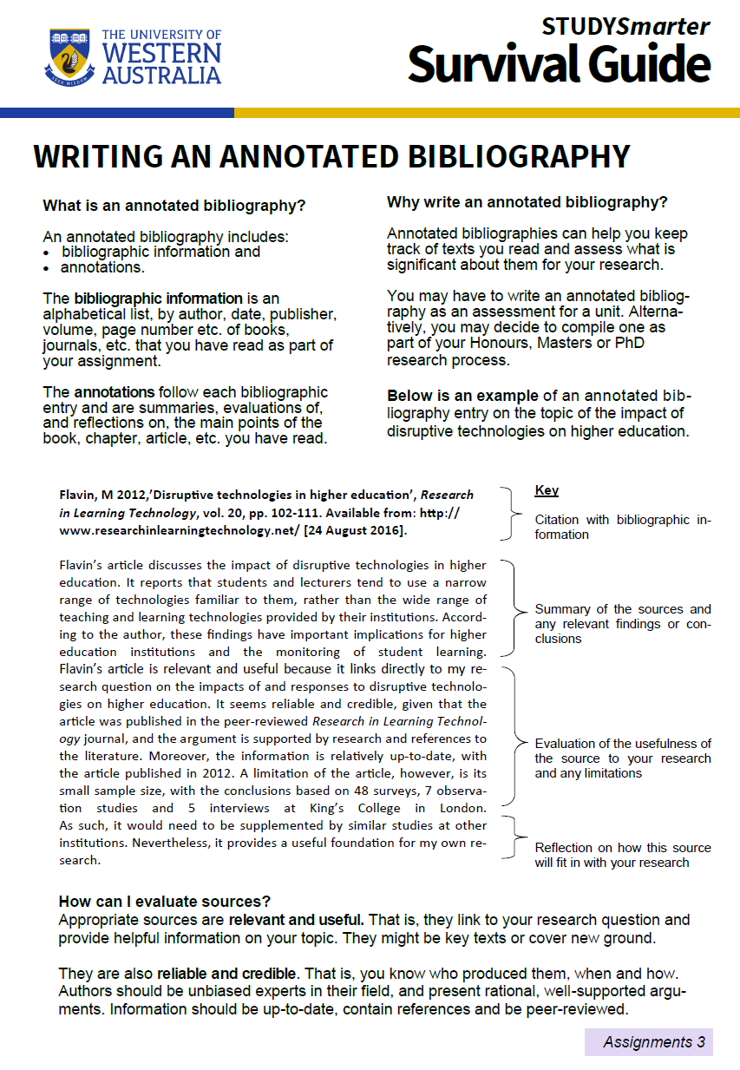

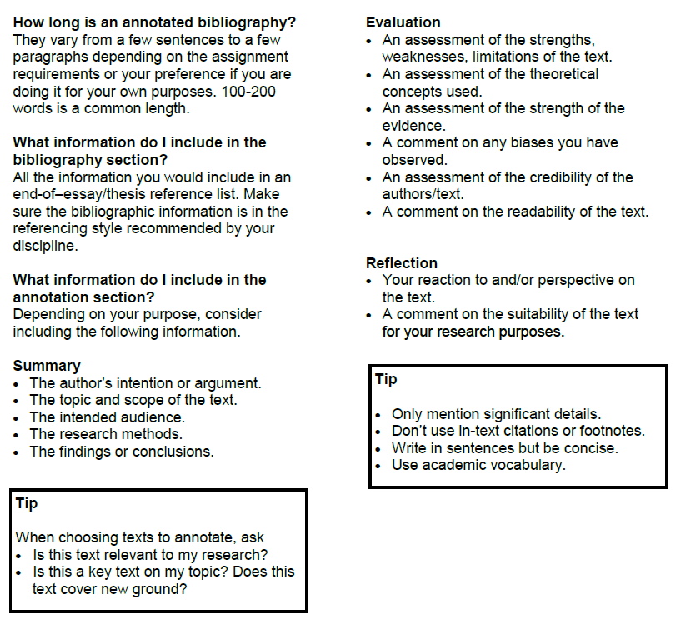

Rationale

* Write an 500-word **reflection/ rationale** answering the following question. You may use first person in this response:

***Assess the causes and consequences of the events, people and ideas presented.***

You will need to include the following:

- An explanation of the significance of the events, people and ideas presented,

- Why you chose your topic and your hypothesis

- Explain the purpose behind how and why you presented your them in your virtual museum display/crash course.

**Draft your response below:**

|  |
| --- |
|  |
|  |
|  |
|  |
|  |
|  |
|  |
|  |
|  |
|  |
|  |
|  |
|  |
|  |
|  |
|  |
|  |
|  |
|  |
|  |
|  |
|  |